**EXPERIMENT 5**

**Aim:** Configuring Access Point with Point to Multi Point.

**Theory:**

**Definition**: In Wi-Fi network, **Bridge mode** allows two or more wireless access points (APs) to communicate with each for the purpose of joining multiple LANs.

Some wireless bridges support only a single **point-to-point** connection to another AP. Others support **point-to-multipoint** connections to several other APs. This article is about to setup a Point to Multi-Point Bridge.

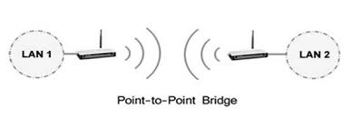

For setting up such network as the above topology by Point to Multi-Point Bridge mode, you need to configure the Access Point A to Point to Multi-Point Bridge mode and points to Access Point B and Access Point C; you also need to configure both Access Point B and Access Point C to "**Point to Point Bridge mode**" and point them to Access Point A.

**Step 1:**

Connect your computer to the AP which will be configured to Point to Multi-Point Bridge mode (**Access Point A**, and then log into the Web-based Interface by entering the IP address**192.168.1.1** or **192.168.1.254**into the address bar of the Web Browser.

**Step 2:**

Change the LAN IP address of the access point to avoid IP conflict.

After changing the IP address of your access point, you need to re-log into it by using the new IP address. And please note that the IP addresses of the access points cannot be the same in your network.

**Step 3:**

Configure your Access Point **A** to **Point to Multi-Point Bridge** mode.

1. Click on **Wireless ->Basic Settings**on the left menu, change the **channel** to a fixed one.

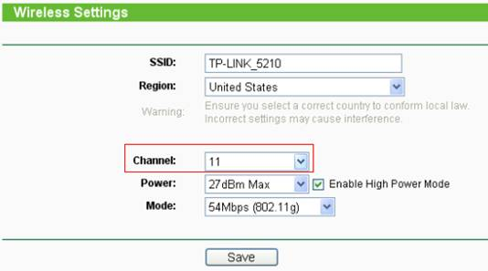

1. Go to **Wireless -> Wireless Mode** on the left, select Bridge (Point to Multi-Point).

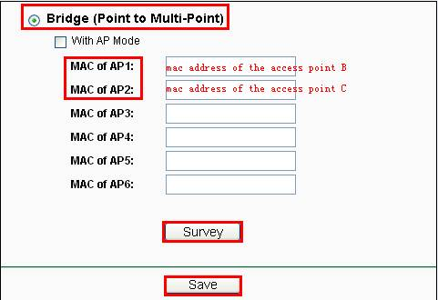

1. Press Survey or Search button and an AP list will be displayed. Locate the BSSID (MAC address) of the access point B and access point C, remember the Channel-> Click Connect.

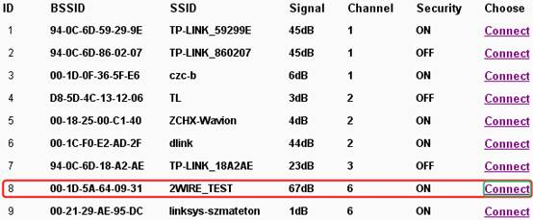

1. Then you will see the MAC addresses of the Access Point B and C are displayed in the MAC of AP boxes.
2. Click on Save button to save the settings.
3. Go to Wireless-Security Settings to secure the wireless as WEP. Note that it only supports WEP when the AP is configured as bridge mode. See more details here Supported Security Types of TP-Link Access Points.
4. Go to System Tools-Reboot to reboot the device.



**Step 4:**

Configure your Access Point B and Access Point C to Point to Point Bridge mode.

**Additional information:**

There is an option called With AP Mode in the setting page. If you enable it, the access point can work in AP mode at the same time when it has been configured to Bridge mode. This means that you can connect other wireless clients to this access point when it has been configured to Bridge mode.

Otherwise, you cannot connect any wireless client to this access point when it has been configured to Bridge mode.